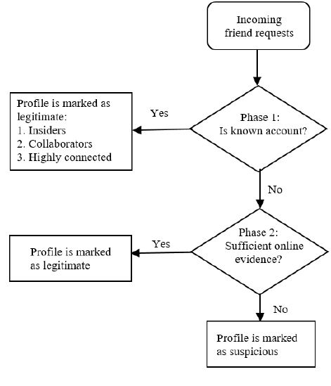Algorithm for detection of suspicious profiles(friends)

Sentiment Analysis Done

Profile picture available or not….? Done

Number of mutual friends….?

Send friend request to more them two artificial profile in the same day, listed as “ head of organization” with no extra information.

Mismatch of profile information with the information available with organization’s team.

Repetition of same tweets …?

Bad Tweets and retweets ratio….?

Bot or Not….?

Account age….? Done